COMP 6231 - Distributed System Design

Assignment 2

By Vasu Ratanpara (Student ID: 40135264)

* **Distributed System Architecture**

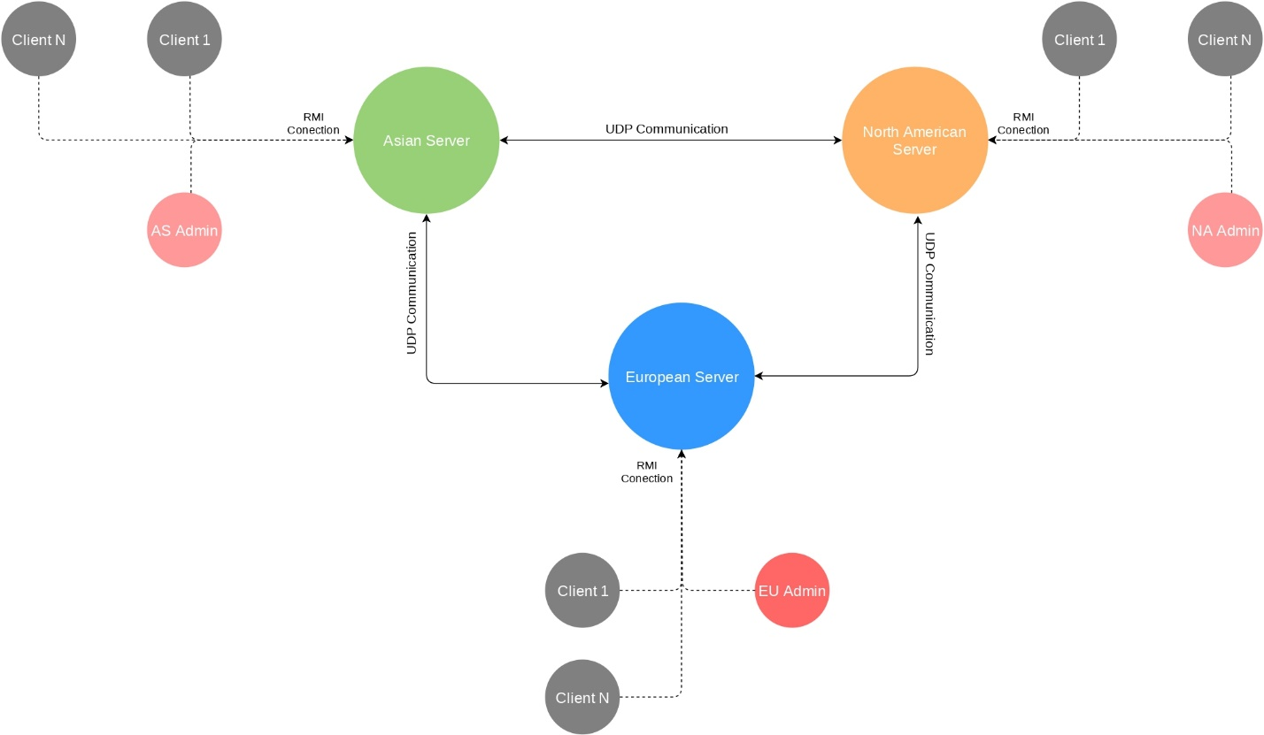

* **RMI Registry Ports**

1. AS_REGISTRY_PORT = 52575
2. EU_REGISTRY_PORT = 52576
3. NA_REGISTRY_PORT = 52577

* **UDP Server Ports**

1. NA_PORT = 5001
2. EU_PORT = 5002
3. AS_PORT = 5003

**Note**: Please kill all services which are running on above port and after that run the project.

* **Asian Server's Default Users (182.x.x.x)**

|  |  |  |
| --- | --- | --- |
| **Sr. No** | **Username** | **password** |
| 1 | Bruce123 | Bruce123 |
| 2 | Charles123 | Charles123 |
| 3 | Adak123 | Adak123 |
| 4 | Varun123 | Varun123 |
| 5 | Kevin123 | Kevin123 |

* **European Server's Default Users (93.x.x.x)**

|  |  |  |
| --- | --- | --- |
| **Sr. No** | **Username** | **password** |
| 1 | tapani15 | Fabienne123 |
| 2 | ksammie45 | Darcie123 |
| 3 | aphilipa22 | Philipa123 |
| 4 | Amsel97 | Davinia123 |
| 5 | Key007 | Gyles123 |

* **North American Server's Default Users (132.x.x.x)**

|  |  |  |
| --- | --- | --- |
| **Sr. No** | **username** | **password** |
| 1 | Siddall123 | Siddall123 |
| 2 | Morce123 | Morce123 |
| 3 | Seabrook123 | Seabrook123 |
| 4 | Upton123 | Upton123 |
| 5 | Garfield123 | Garfield123 |

* **How to run project?**

The project was created using Oracle’s Java 14.

Unzip project submission. There will be 1 file and 1 folder namely “Readme.pdf” and “Assignment 1” folder. Put “Assignment 1” folder in your Eclipse workspace and open the project in your Eclipse.

There are 3 packages in the folder namely Client, Server and Logger.

* **src folder**

1. Client package
   * AdministratorClient.java
   * PlayerClient.java
2. Server package
   * GameServer.java (RMI Interface)
   * AsianServer.java (Asian Server)
   * AsianServerImpl.java
   * EuropeanServer.java (European Server)
   * EuropeanServerImpl.java
   * NorthAmericanServer.java (NorthAmerican Server)
   * NorthAmericanServerImpl.java
3. Logger package
   * FileLogger.java

* **logs folder**

1. PlayerClient

* PlayerClientLogs.log

1. AdministratorClient
   * AdministratorClientLogs.log
2. ServerLogs

* NorthAmericanServer

1. NorthAmericanServer.log
2. UserLogs (It has all North American users’ log files)
   * EuropeanServer
3. EuropeanServer.log
4. UserLogs (It has all European users’ log files)
   * AsianServer
5. AsianServer.log
6. UserLogs (It has all Asian users’ log files)

* **Staring Asian Server**

* **Starting European Server**

* **Starting North American Server**

* **Starting PlayerClient**

* **Staring AdministratorClient**

* **Creating New User Account**

* **Signing in User Account**

* **Signing out User Account**

* **Get Player Status (by Admin)**

* **Validations**
  + IP Validation

* + Age, Username and Password validations

* **Logs**

Logs folder will be created in the eclipse project folder

Here you can see “logs” folder with “src” and “bin” folder

There are 3 folders inside “logs” folder

Inside “ServerLogs” folder there is sperate folder for each servers which contains the logs for individual servers and their users.

Server’s log file will be stored outside and Admin’s log are stored in ”AdminLogs” folder and users’ logs will be stored in “UserLogs” folder

Here, As you can see there are 5 folders for 5 different user (by username) each folder contains individual log files for each user

User log for player with username ”Varun123”.

* **Exiting Program**

* + Feel free to contact me if you do not understand anything or you have any questions. My email address is [vasu.ratanpara@mail.concordia.ca](mailto:vasu.ratanpara@mail.concordia.ca)

Thank You